The Gender Divide
For Classroom discussion only

“There is definitely a gender discrimination in our company”, said Swetha. “Thanks to the assignment I got from Yajvin, I got access to salary and other details of large number of our people in our company. As you know, our company keeps all these details extremely confidential. The accounts have the salary data, but they don’t have access to other information about the employees. Only a few people at the top have access to all the data. Yajvin asked me to do some preliminary analysis of the salaries and I was given access to the data on salaries as well as the background information of the employees. My preliminary analysis clearly shows that women in this company are discriminated against!”.
Swetha is part of the internal audit team in NS Software Services Ltd., popularly known as NS3. Yajvin recently joined the company as the Senior Vice President, Human Resources. He wanted to implement a set of guidelines for fixing the salary as well as annual increments. He has asked Swetha to do some preliminary analysis based on the data available with the HR department and the Finance and Accounts department.
“I am not sure about the gender discrimination in our company”, said Dhanvin. “I do have a feeling that there are many women here who draw more salary than I do. I always had a feeling that our salaries are fixed based on various factors such as educational background, years of experience, Level in the company etc. Also, why are you talking about salary only; don’t you think you should look at the entire compensation, both fixed and variable?”.
Dhanvin is one of the Project leaders in NS3. He came from technology background with an IIT degree and an IIM diploma. He has been with the company long enough to understand the way the fixed and variable components of compensation work in the company. He knew that in his own case, the variable component is much higher than the fixed component.
NS3 divides the employee compensation into two components. The first is the fixed component, which is the monthly salary. The second is the variable component given to the employees at different stages. Being a project based organization, the team members are given a monetary incentive whenever a project is completed. The incentive is calculated based on the earned value of the project as well as the contribution of the project to the bottom line. In addition, there are other variable compensation components such as annual bonus, ESOPs etc.
“Yajvin thinks that the variable component is the payment made to employees towards their efficiencies. It also depends upon the kind of projects one gets into. He feels that, it is the fixed component, i.e, the salary that can be controlled with appropriate guidelines”, said Swetha. “As a matter of fact, I have access only to salary data and not to the variable component data. So, I cannot do any analysis with variable component, even if I want to”.
Swetha tried to analyze the relationship between salary (as on date) and various other factors such as gender, educational background (type of degree), years of experience in the company, years of work experience prior to joining the company, age of the employee and level in the organization. NS3 categorizes its employees into 6 Levels. Level A is the lowest (new recruits, taken directly after graduation) and Level F is the top level. Levels B, C, D and E are in between.
Swetha used scatter plots to understand the relationship between salary and each of the factors. Some of the relationships revealed by the scatter plots are as expected. For example, a positive relationship is exhibited between years of experience within the company and the salary. Similarly, there is a positive relationship between salary and different levels in the organization. These scatter plots are presented in the Appendix 2.
The scatter plot of salary with gender showed an interesting relationship. There are very few women with higher salary levels. This was the main basis for Swetha to conclude that there is a discrimination against women in the company. She had decided to test her hypothesis with a two-sample mean test using SPSS. The results of the hypothesis test are presented in the Appendix 1.

Appendix 1.
SPSS output on two-sample means test

Group Statistics
 | Gender | N | Mean | Std. Deviation | Std. Error Mean
Salary | 0 | 66 | 545158.18 | 191287.239 | 23545.831
Salary | 1 | 134 | 443981.19 | 79626.439 | 6878.677

Independent Samples Test
 |  | Levene's Test for Equality of Variances |  | t-test for Equality of Means
 |  | F | Sig. | t | df | Sig. (2-tailed) | Mean Difference | Std. Error Difference | 95% Confidence Interval of the Difference
 |  |  |  |  |  |  |  |  | Lower | Upper
Salary | Equal variances assumed | 30.466 | .000 | 5.275 | 198 | .000 | 101176 | 19182 | 63349 | 139004
Salary | Equal variances not assumed |  |  | 4.125 | 76.297 | .000 | 101176 | 24530 | 52324 | 150029

oAppendix 2.
Scatter Plots showing relationship between Salary and other factors
Graph 1. Salary Vs. Gender
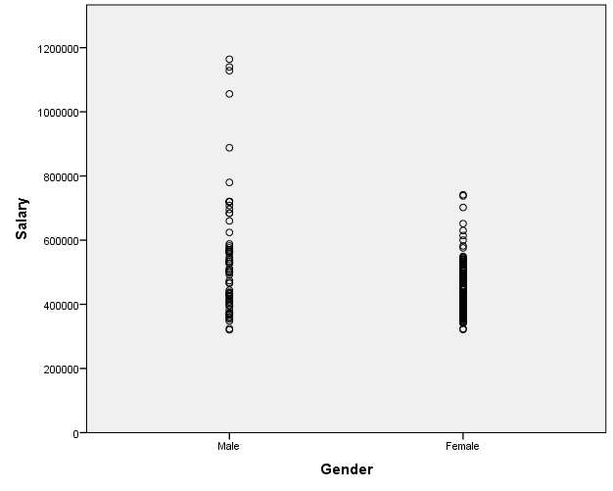

Graph 2. Salary Vs. Type of Degree
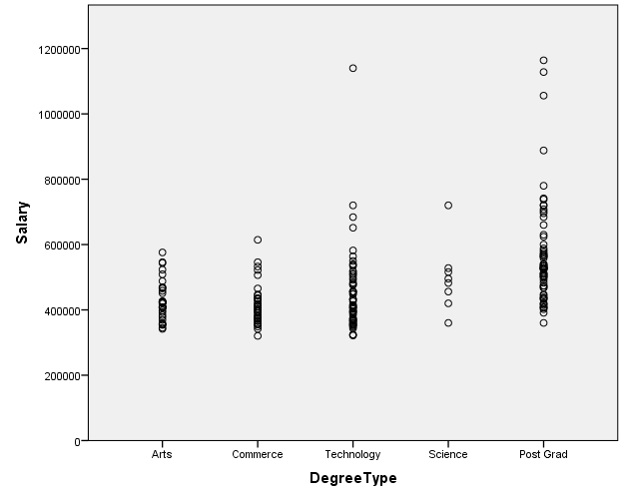

Graph 3. Salary Vs. Level in the Company
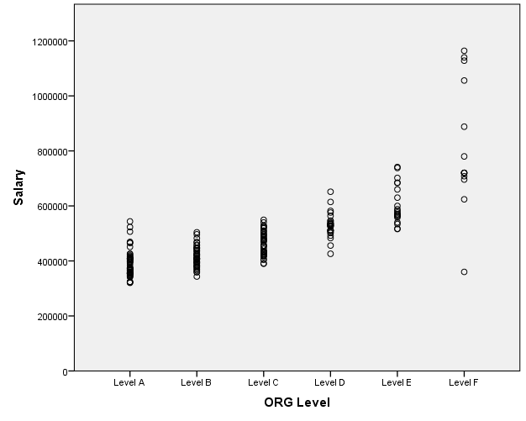

Graph 4. Salary Vs. Experience in the company
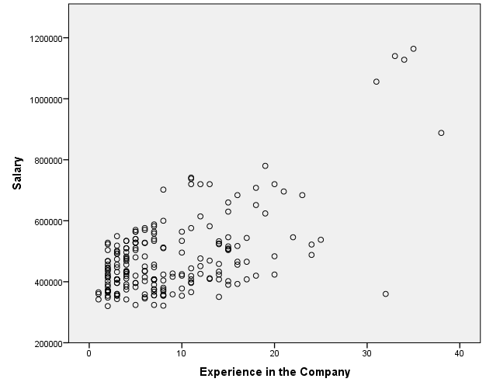

Graph 5. Salary Vs. Prior Experience
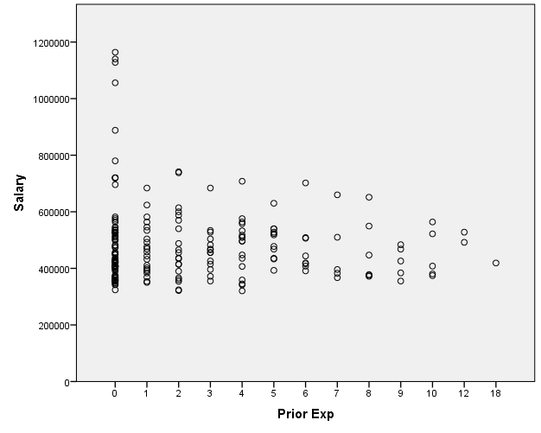

Graph 6. Salary Vs. Age
